User manual change detection

Purpose
Detect anomalous values in NDVI time series. An anomalous value is determined as follows:
- Spatial filtering by class (from a second input file)
- Extracting valid ranges from a table with the class as key
- Anomalous values are outside this valid range.

Installation
Install the .sav files in the save_add folder (see also ENVI .sav files: Installation and configuration.
change_detection_gui.sav The anomaly detecting software
nrs_utils.sav Utility routines

Usage (GUI)
Starting is possible from the command line:
change_detection_GUI
, or from the ENVI menu ‘NRS | Change detection…’, which starts the following dialog:
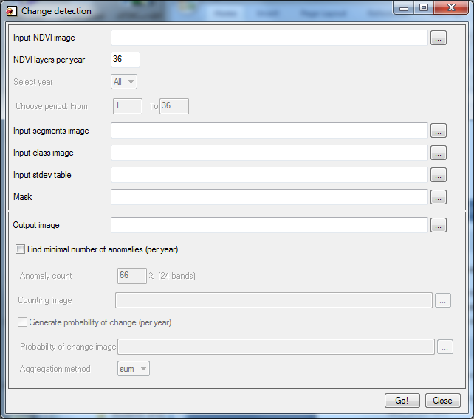
The dialog consists of an input section and an output section.
The input section has fields to enter the input NDVI stack, the number of NDVI layers per year, selection of a year in the input, selection of a period in the year(s), optionally a segments image, the classified image, the table with the standard deviation values, and an optional mask image.
The output section contains a field to enter the name of the change detection output. It also contains fields to aggregate the change detection result. One section lets the user specify a minimal sequence length of changes before a location is flagged as an anomaly; the output is written to a file. The second option allows the user to also calculate the absolute differences between the actual value and the valid range. The valid range for a location is defined by the aggregated value of all values in the layer per class and the standard deviation as specified by the table file (per layer, per class); the aggregation of the magnitude can be selected to be: average, sum, min and max. The output is written to a file.
The optional mask will be applied to remove unwanted locations.
Running the calculations will display a progress bar to indicate the progress visually:
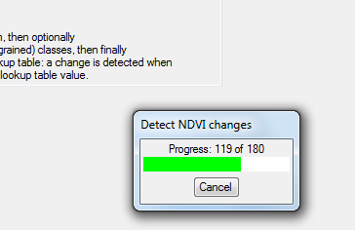

Output data
The software generates up to three files:
- Change detection: per layer of the input changes are detected. The layer names follow the pattern ‘Year nr Y.P’, where Y indicates the year number (from 1) and P indicates the period (from 1)
- Count detection: aggregated per year. Per year indicates whether the number of anomalies (N) is higher than specified by the user: 1: contains more than or equal to N; 0: contains less than N. The layer names follow the pattern ‘Year YY’, where YY indicates the year (from 1)
- Magnitude: aggregated per year. For each non-zero value in ‘count detection’ gives the distance from the standard deviation in the change detection data (file 1). The layer names follow the pattern ‘Magnitude (year YY)’, where YY indicates the year (from 1)

